Intro to programming

Ezzat Mohamed

Vending machine

**Introduction**

This vending machine is a python coding application of a real world vending system. However, This program is built using python coding, this coding focuses on creating friendly experience. This type of project is an example of how programming can be used in the real world and problem solving and can be used to solve tasks in the real world. This project is built to show how anything can be created and managed

**Category:**

Firstly we should list the items, each item got its own ID, Name, stock and price. So the user can know the item there choosing Here is a example:

Item 1: Water, Priced at 1.50 with stock of 20

Item 2: Soda, Priced at 3.50 with stock of 7

This way the users are able and greeted with an organized way so they can see the products or items and choose whatever they want. All items are stored and kept in a key value in this dictionary.

For example if you press 1 for water so in the dictionary it is containing the details about the item like (id, name, price, stock)

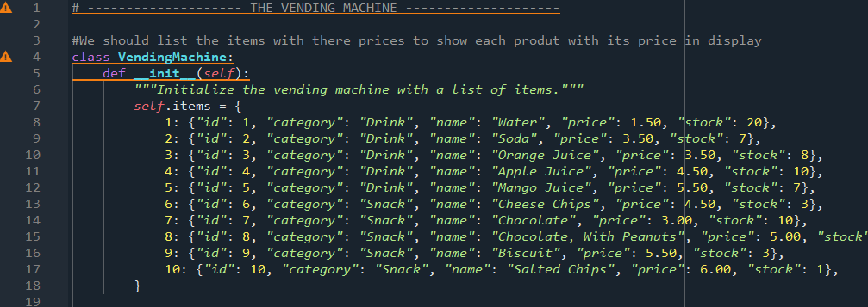

**Displayed Items**

Displayed items is a way that allows to display and show the available items in the vending machine, this makes it easier for users, while the items are displayed into two groups (Drinks and Snakes), However it uses (_show_items_by_category) to display the items for every category to make it easier and not complicated for users.

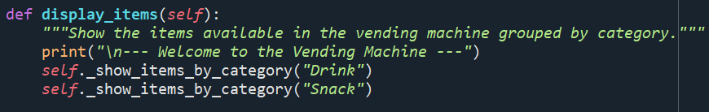

**Showing the items by category**

This way to show category to users that can helps in many ways so This method filters and prints the items based on their category for example if i choose (item 1, Water) it prints for me the item's ID, name, price for every item i choose and it loops through (self.items) however it checks if each of the items matches the category and if the user chooses another ID the category would not appear for the user and the user should write or type another ID so the category could appear and the items would appear for the user.

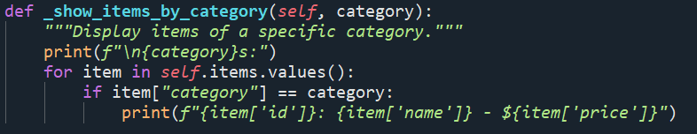

**Allowing Users to Select items**

Allowing users to select items is a way that makes the user type or write the item ID. This Method it makes the user choose the items that they want and add them to their ‘cart’.

Before buying an item from the vending machine it asks the user to enter the item ID and checks if its available or invalid and it shows how many quantity is there so the user can add them to the cart and the user can choose multiple items by typing their ID and then it asks the user if they want to buy another items if not they would continue to the next step

Cart: It’s the list where when you select an item its stored with its price, name, and quantity 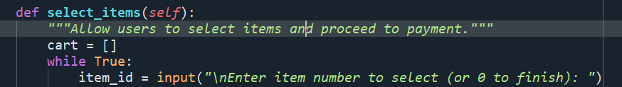

**Checking if the Item ID is valid**

This method makes sure that the user entered the correct item ID or number and if it's the wrong ID the vending machine would ask him to retype or rewrite the item ID or number again.

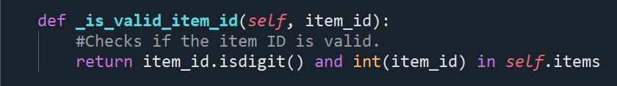

**Quantity of the items**

By showing the users the quantity of the items it helps the users to specify in how many quantity they would like to get, at the same time the quantity must be more than 0 or equal to the available stock, By typing different ID that isn't shown in the list it won't process and the vending machine won't continue to the next step, the user must write or type the correct item ID so the vending machine get the users their items

If the item is out of stock the vending machine would ask the user to type a different iD so it can process and continue to the next step.

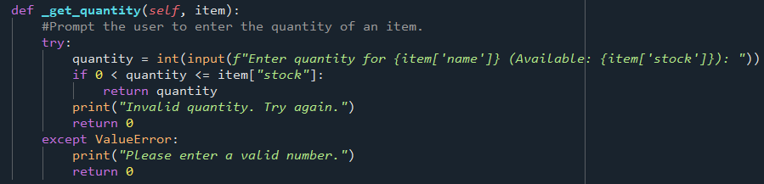

**Payment processing**

Payment processing is a way to calculate the total cost of the items that has been selected and the quantity and the way it works is it calculates the total cost of every item that has been kept in the cart and the customer would enter the payment and then it calculates and gives back the users change and if the payment is not enough the vending machine would not process and the user would type the amount again.

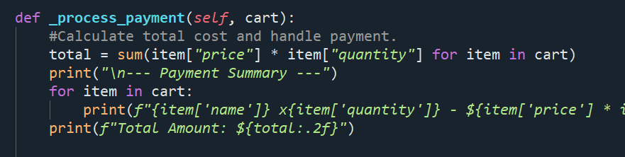

**Printing Receipt**

After payment the customer would receive a receipt giving the customer a receipt with every thing that he bought like the name, quantity, and the cost of every item and it will even show the payment amount and the change that is left for the customer

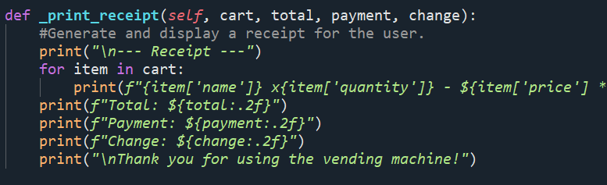

**Conclusion**

This vending machine is an example of how vending machines work and how easily you can use python to code that is easily made and it simulates a real world vending machine. It acts like a real vending machine and shows every single item. However, this python code has a practical skills that helps in a strong understanding how software connects and interacts with real world scenario